**메일 서버 구축**

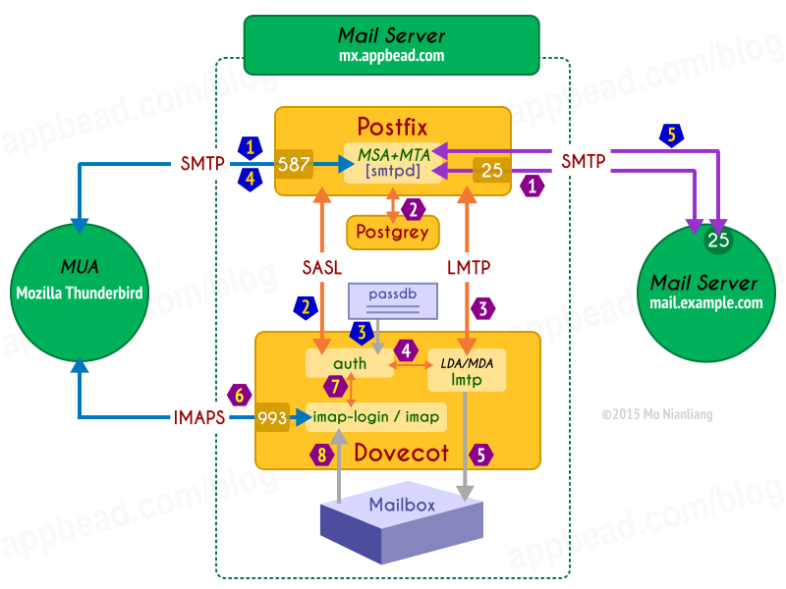

MSA : Mail Submission Agent

MUA : Mail User Agent

MTA : Mail Transport Agent

MDA : Mail Delivery Agent

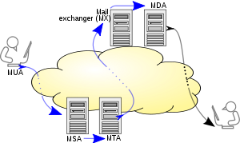

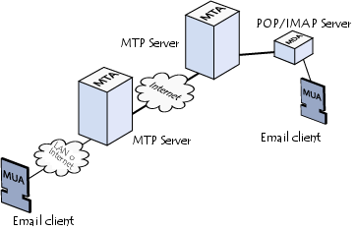

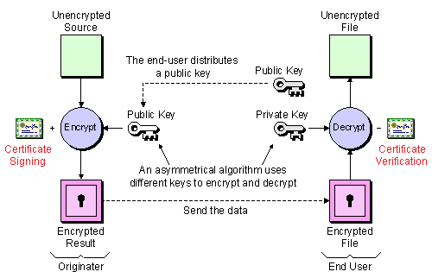

**Postfix나 dovecot를 ssl인증 설정을 하는 이유는 통신 시 위 방식으로 암호화 이유.**

**Sending Email**

When you composes a message, and clicks the Send button in your MUA mail user agent (Mozilla Thunderbird), the following events takes place.

1. The MUA use SMTP protocol send request of authentication to the Submission port 587 on our mail server (mx.appbead.com). The handler of that port is called a MSA, it's a process of **smtpd** in Postfix.

단말이든 클라이언트에서 메일을 보내면 그 서버/단말의 587 포트로 smtp프로토콜 기반으로 메일을 제출

1. The MSA handing off request of authentication to Dovecot use SASL protocol, and the **auth** process of Dovecot is responsible for authentication.

dovecot에게 사용자 인증을 요청해서 인증 수행

1. The **auth** process check the pair of user name and password with **passdb** (in this case it's a passwd-file), and return a result indicate that the authentication is successful or not.

파일기반 passwd인증을 수행

1. When the user is authenticated, the MSA queue this message.

인증 후 postfix의 queue에 메시지 입력

1. Postfix sends all messages in the queue to their destination automatically. You may check the section [Operation overview](http://en.wikipedia.org/wiki/Email#Operation_overview) of Email on Wikipedia, for more details.

Postfix 는 메일을 전달

**Receiving Email**

1. The outside mail server mail.example.com, query our DNS server for any [MX records](http://en.wikipedia.org/wiki/MX_record) of our domain appbead.com, to get the IP of our mail server. And then use SMTP protocol sends message to the port 25 on our mail server, the handler of port 25 is called MTA, it's another process of **smtpd** in Postfix.

해당 도메인의 MX 질의를 하면 메일 서버을 찾게 되고, The MTA apply all restrictions on the message, to determine the message should be rejected or relay to LDA. It checks access control, authenticated destination, RBL, RHSBL, SPF and Postgrey etc.

인증, 제한 여부 확인

1. If the message should not be rejected, then the MTA uses the LMTP protocol to transmit the message to a LDA/MDA. Here, a **lmtp** process of Dovecot takes the LDA/MDA task.
2. The **lmtp** process query the **auth** process, to get information of mailbox for the recipient. The **auth** process read **passdb** and **userdb** to get that information.
3. If **auth** returns a valid path of mailbox, the message will be stored to its mailbox. Otherwise, **lmtp** will reject a message as it is not deliverable, then Postfix will send a mailer-daemon message to sender for notification.

인증이 성공하고 메시지는 메일박스에 저장됨,.

1. The MUA use IMAPS protocol send request of authentication to the IMAPS port 993 on our mail server mx.appbead.com, and the handler of that port is a process of **imap-login** in Dovecot.

메시지를 수신해 보고 싶으면 imaps프로토콜 통해서 질의가능

1. The **imap-login** process handing off request of authentication to the **auth** process, then **auth** check **passdb** and return result to **imap-login**.
2. If the authentication is successful, the **imap-login** process keep proxying the connection to a **imap** process. Then the **imap** process read messages from mailbox, and transmit it to the MUA.

<https://appbead.com/blog/how-to-setup-mail-server-on-debian-8-jessie-with-postfix-dovecot-1.html>

[root@localrepo ~]# **yum install -y dovecot**

**메일 서버는 크게 두종류의 프로그램과 두종류의 프로토콜로 전달됨**

**MTA(메일 전송 프로그램) : sendmail등**

**MUA(메일 클라이언트 프로그램) : outlook 등**

**프로토콜은**

**메일 전송 : SMTP**

**받은 메일 🡪 클라이언트 : POP3, IMAP**

**CentOS에서는 Dovecot이란 IMAP 사용**

Loaded plugins: fastestmirror, langpacks

Repository base is listed more than once in the configuration

Repository updates is listed more than once in the configuration

Repository extras is listed more than once in the configuration

Loading mirror speeds from cached hostfile

* base: ftp.tsukuba.wide.ad.jp

* extras: www.ftp.ne.jp

* updates: ftp.riken.jp

Resolving Dependencies

--> Running transaction check

---> Package dovecot.x86_64 1:2.2.10-7.el7 will be installed

--> Finished Dependency Resolution

Dependencies Resolved

====================================================================

Package Arch Version Repository Size

====================================================================

Installing:

dovecot x86_64 1:2.2.10-7.el7 base 3.2 M

Transaction Summary

====================================================================

Install 1 Package

Total download size: 3.2 M

Installed size: 9.8 M

Downloading packages:

dovecot-2.2.10-7.el7 35% [===- ] 0.0 B/s | 1.1 MB --:-- ETA dovecot-2.2.10-7.el7 97% [=========-] 2.6 MB/s | 3.1 MB 00:00 ETA dovecot-2.2.10-7.el7.x86_64.rpm | 3.2 MB 00:00

Running transaction check

Running transaction test

Transaction test succeeded

Running transaction

Installing : 1:dovecot-2.2.10-7.el7 [ ] 1/1 Installing : 1:dovecot-2.2.10-7.el7 [# ] 1/1 Installing : 1:dovecot-2.2.10-7.el7 [## ] 1/1 Installing : 1:dovecot-2.2.10-7.el7 [### ] 1/1 Installing : 1:dovecot-2.2.10-7.el7 [#### ] 1/1 Installing : 1:dovecot-2.2.10-7.el7 [##### ] 1/1 Installing : 1:dovecot-2.2.10-7.el7 [###### ] 1/1 Installing : 1:dovecot-2.2.10-7.el7 [####### ] 1/1 Installing : 1:dovecot-2.2.10-7.el7 [######## ] 1/1 Installing : 1:dovecot-2.2.10-7.el7 [######### ] 1/1 Installing : 1:dovecot-2.2.10-7.el7 [########## ] 1/1 Installing : 1:dovecot-2.2.10-7.el7 [########### ] 1/1 Installing : 1:dovecot-2.2.10-7.el7 [############ ] 1/1 Installing : 1:dovecot-2.2.10-7.el7 [############# ] 1/1 Installing : 1:dovecot-2.2.10-7.el7 [############## ] 1/1 Installing : 1:dovecot-2.2.10-7.el7 [############### ] 1/1 Installing : 1:dovecot-2.2.10-7.el7 [################ ] 1/1 Installing : 1:dovecot-2.2.10-7.el7 [################# ] 1/1 Installing : 1:dovecot-2.2.10-7.el7 [################## ] 1/1 Installing : 1:dovecot-2.2.10-7.el7 [################### ] 1/1 Installing : 1:dovecot-2.2.10-7.el7 [#################### ] 1/1 Installing : 1:dovecot-2.2.10-7.el7 [##################### ] 1/1 Installing : 1:dovecot-2.2.10-7.el7 [###################### ] 1/1 Installing : 1:dovecot-2.2.10-7.el7.x86_64 1/1

Verifying : 1:dovecot-2.2.10-7.el7.x86_64 1/1

Installed:

dovecot.x86_64 1:2.2.10-7.el7

**[root@localrepo ~]# tail -2 /etc/dovecot/conf.d/10-auth.conf 🡪 인증 설정**

**mail_location = mbox:~/mail:INBOX=/var/mail/%u**

**disable_plaintext_auth = no**

**[root@localrepo ~]# tail -1 /etc/dovecot/dovecot.conf 🡪 메일 수신 프로토콜**

**protocols = imap**

**[root@localrepo ~]# cat /etc/dovecot/conf.d/10-master.conf 🡪 dovecot 기본 설정**

**service imap-login {**

**inet_listener imap {**

**}**

**inet_listener imaps {**

**}**

**}**

**service pop3-login {**

**inet_listener pop3 {**

**}**

**inet_listener pop3s {**

**}**

**}**

**service lmtp {**

**unix_listener lmtp {**

**}**

**}**

**service imap {**

**}**

**service pop3 {**

**}**

**service auth {**

**unix_listener auth-userdb {**

**}**

**unix_listener /var/spool/postfix/private/auth {**

**mode = 0660**

**user = postfix**

**group = postfix**

**}**

**}**

**service auth-worker {**

**}**

**service dict {**

**unix_listener dict {**

**}**

**}**

[root@localrepo ~]# **cat /vi /etc/pki/dovecot/dovecot-openssl.cnf 🡪 openssl 설정**

**[ req ]**

**default_bits = 1024**

**encrypt_key = yes**

**distinguished_name = req_dn**

**x509_extensions = cert_type**

**prompt = no**

**[ req_dn ]**

**# country (2 letter code)**

**#C=FI**

**# State or Province Name (full name)**

**#ST=**

**# Locality Name (eg. city)**

**#L=Helsinki**

**# Organization (eg. company)**

**#O=Dovecot**

**# Organizational Unit Name (eg. section)**

**OU=IMAP server**

**# Common Name (*.example.com is also possible)**

**CN=imap.example.com**

**# E-mail contact**

**emailAddress=postmaster@example.com**

**[ cert_type ]**

**nsCertType = server**

[root@localrepo ~]# **openssl req -new -x509 -nodes -config /etc/pki/dovecot/dovecot-openssl.cnf -out /etc/pki/dovecot/certs/dovecot.pem -keyout /etc/pki/dovecot/private/dovecot.pem -days 365**

Generating a 1024 bit RSA private key

............................................................................++++++

..............++++++

writing new private key to '/etc/pki/dovecot/private/dovecot.pem'

-----

[root@localrepo ~]# **chmod 0600 /etc/pki/dovecot/certs/dovecot.pem**

**/etc/pki/dovecot/private/dovecot.pem 🡪 인증서와 키 권한 변경**

[root@localrepo ~]# **chown root:root /etc/pki/dovecot/certs/dovecot.pem**

**/etc/pki/dovecot/private/dovecot.pem 🡪 인증서와 키 파일 소유자 변경**

[root@localrepo ~]# **openssl x509 -subject -fingerprint -noout -in /etc/pki/dovecot/certs/dovecot.pem 🡪 fingerprint 생성**

subject= /OU=IMAP server/CN=imap.example.com/emailAddress=postmaster@example.com

SHA1 Fingerprint=AA:97:BF:AF:C2:36:40:CF:53:89:28:6C:55:36:BD:41:5C:08:D7:09

[root@localrepo ~]# **systemtctl enable dovecot**

Created symlink from /etc/systemd/system/multi-user.target.wants/dovecot.service to /usr/lib/systemd/system/dovecot.service.

[root@localrepo ~]# **systemctl start dovecot**

dovecot.service - Dovecot IMAP/POP3 email server

Loaded: loaded (/usr/lib/systemd/system/dovecot.service; enabled; vendor preset: disabled)

Active: active (running) since 2017-04-04 18:15:44 KST; 6s ago

Process: 25911 ExecStartPre=/usr/libexec/dovecot/prestartscript (code=exited, status=0/SUCCESS)

Main PID: 25915 (dovecot)

CGroup: /system.slice/dovecot.service

25915 /usr/sbin/dovecot -F

25916 dovecot/anvil

25917 dovecot/log

25919 dovecot/config

4 04 18:15:44 localrepo systemd[1]: Starting Dovecot IMAP/POP...

4 04 18:15:44 localrepo systemd[1]: Started Dovecot IMAP/POP3...

4 04 18:15:44 localrepo dovecot[25915]: master: Dovecot v2.2....

Hint: Some lines were ellipsized, use -l to show in full.

[root@localrepo ~]#

**여기부터는 postfix**

[root@localrepo ~]# **yum install postfix 🡪 메일 전송 설치**

Loaded plugins: fastestmirror, langpacks

Repository base is listed more than once in the configuration

Repository updates is listed more than once in the configuration

Repository extras is listed more than once in the configuration

Loading mirror speeds from cached hostfile

* base: ftp.tsukuba.wide.ad.jp

* extras: www.ftp.ne.jp

* updates: ftp.riken.jp

Package 2:postfix-2.10.1-6.el7.x86_64 already installed and latest version

Nothing to do

**[root@localrepo ~]# postconf -e "mysnetworks = 10.10.10.0/24"**

**[root@localrepo ~]# postconf -e "smtpd_sasl_auth_enable = yes"**

**[root@localrepo ~]# postconf -e "smtpd_sasl_type = dovecot"**

**[root@localrepo ~]# postconf -e "smtpd_+sasl_path = private/auth"**

**[root@localrepo ~]# postconf -e "smtpd_recipient_restrictions = perm it_mynetworkm per, mpermit_sasl_authenkticaated, reject_unauth_destination"**

**[root@localrepo ~]# postconf -e "smtpd_tls_security_level = may"**

**[root@localrepo ~]# postconf -e "smtpd_tls_key_file = /etccert_file = /etc/pki/tls/ certs/postfix.pem"**

**[root@localrepo ~]# postfconf -e "smtpd_tls_ekkey_file = /etc/pki/tls/private /postfix.pem"**

[root@localrepo ~]# vi /etc/postfix/masster.cf

* Postfix 설정, ssl,

[root@localrepo ~]# **cat /etc/pki/tls/postfix-openssl.cnf 🡪 postfix 사용할 인증, 키 생성을 위한 openssl 설정**

[ req ]

default_bits = 1024

encrypt_key = yes

distinguished_name = req_dn

x509_extensions = cert_type

prompt = no

[ req_dn ]

# country (2 letter code)

#C=FI

# State or Province Name (full name)

#ST=

# Locality Name (eg. city)

#L=Helsinki

# Organization (eg. company)

#O=Dovecot

# Organizational Unit Name (eg. section)

OU=IMAP server

# Common Name (*.example.com is also possible)

CN=smtp.example.com

# E-mail contact

emailAddress=postmaster@example.com

[ cert_type ]

nsCertType = server

[root@localrepo ~]# **openssl req -new -x509 -nodes -config /etc/pki/tls/postfix-openssl.cnf -out /etc/pki/tls/certs/postfix.pem -keyout /etc/pki/tls/private/postfix.pem -days 365**

[root@localrepo ~]# **chmod 0600 /etc/pki/tls/certs/postfix.pem /etc/pki/tls/private/postfix.pem** [root@localrepo ~]# **chown root:root /etc/pki/tls/certs/postfix.pem /etc/pki/tls/private/postfix.pem**

[root@localrepo ~]# **openssl x509 -subject -fingerprint -noout -in /etc/pki/tls/certs/postifx.pem 🡪 fingerprint 생성**

[root@localrepo ~]# systemctl enable postfix

[root@localrepo ~]# systemctl estart postfix

[root@localrepo ~]# systemctl status postfix

postfix.service - Postfix Mail Transport Agent

Loaded: loaded (/usr/lib/systemd/system/postfix.service; enabled; vendor preset: disabled)

Active: active (running) since 2017-04-04 20:38:43 KST; 4s ago

Process: 27478 ExecStop=/usr/sbin/postfix stop (code=exited, status=0/SUCCESS)

Process: 27497 ExecStart=/usr/sbin/postfix start (code=exited, status=0/SUCCESS)

Process: 27493 ExecStartPre=/usr/libexec/postfix/chroot-update (code=exited, status=0/SUCCESS)

Process: 27489 ExecStartPre=/usr/libexec/postfix/aliasesdb (code=exited, status=0/SUCCESS)

Main PID: 27568 (master)

CGroup: /system.slice/postfix.service

27568 /usr/libexec/postfix/master -w

27569 pickup -l -t unix -u

27570 qmgr -l -t unix -u

4 04 20:38:43 localrepo systemd[1]: Starting Postfix Mail Tra...

4 04 20:38:43 localrepo postfix/postfix-script[27566]: starti...

4 04 20:38:43 localrepo postfix/master[27568]: daemon started...

4 04 20:38:43 localrepo systemd[1]: Started Postfix Mail Tran...

Hint: Some lines were ellipsized, use -l to show in full.